Program to print hello world

class Hello{

public static void main(String[] args) {

System.out.println("hello world");

}

}

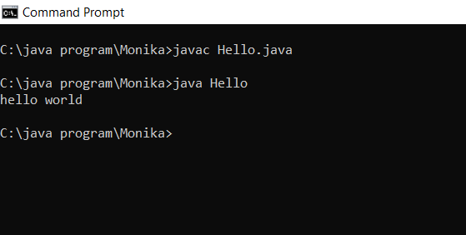

Program to print average of five number

import java.util.\*;

class Acro {

public static void main(String[] args){

Scanner sc = new Scanner(System.in);

System.out.println("Enter the five numbers");

int n1 = sc.nextInt();

int n2 = sc.nextInt();

int n3 = sc.nextInt();

int n4 = sc.nextInt();

int n5 = sc.nextInt();

float avg=(n1+n2+n3+n4+n5)/5;

System.out.println("The average of five numbers is "+ avg);

}

}

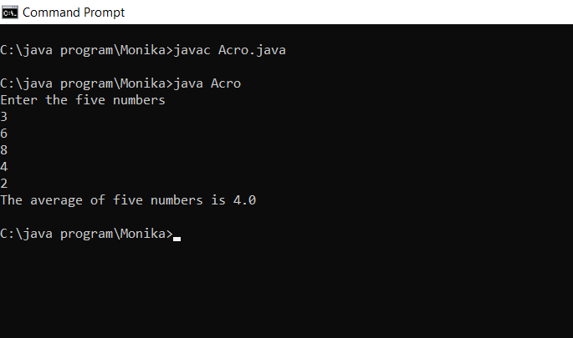

Program to print even or odd number

import java.util.\*;

class Acro {

public static void main(String[] args){

Scanner sc= new Scanner(System.in);

System.out.println("enter the number");

int num = sc.nextInt();

if(num%2==0){

System.out.println("num is even");

}

else{

System.out.println("num is odd");

}

}

}

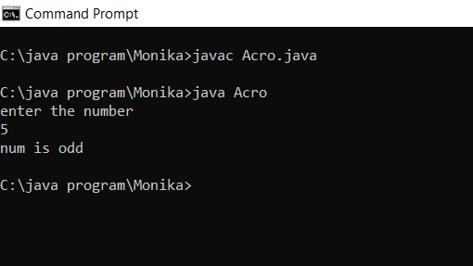

Program to print larger of two number

import java.util.\*;

class Acro {

public static void main(String[] args){

Scanner sc= new Scanner(System.in);

System.out.println("enter the first number");

int num1 = sc.nextInt();

System.out.println("enter the second number");

int num2 = sc.nextInt();

if(num1>num2){

System.out.println(num1+" is greater than "+num2);

}

else{

System.out.println(num2+" is greater than "+num1);

}

}

}

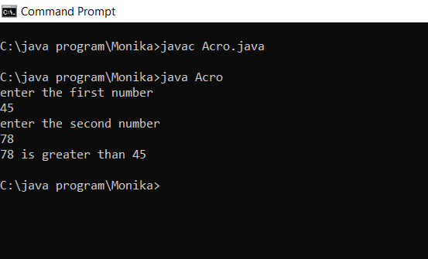

Program to print larger of two number

import java.util.\*;

class Acro {

public static void main(String[] args){

Scanner sc= new Scanner(System.in);

System.out.println("enter the first number");

int num1 = sc.nextInt();

System.out.println("enter the second number");

int num2 = sc.nextInt();

System.out.println("enter the third number");

int num3 = sc.nextInt();

if(num1>num2){

if(num1>num3){

System.out.println("the greatest number is "+num1);

}

}

else if(num2>num3){

if(num2>num1){

System.out.println("the greatest number is "+num2);

}

}

else{

System.out.println("the greatest number is "+num3);

}

}

}

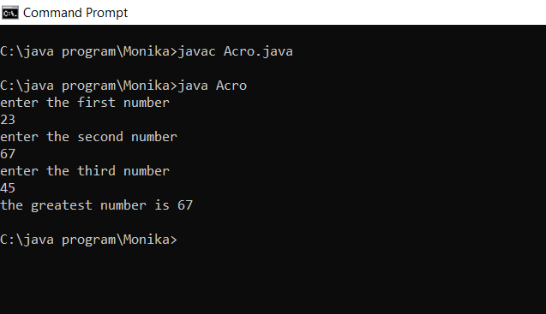

Program to print number from 1 to 10

class Acro {

public static void main(String[] args){

for(int num=1;num<=10;num++){

System.out.println(num);

}

}

}

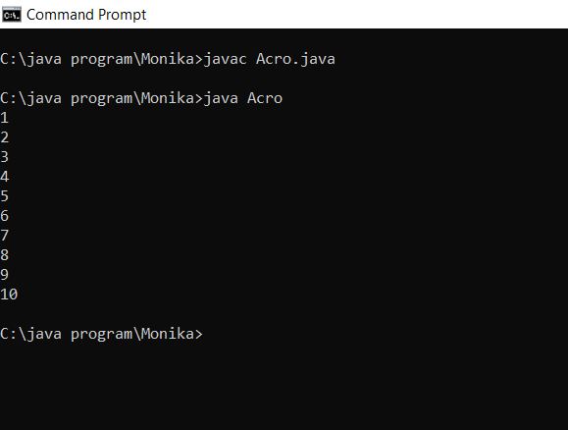

Program to print table of a number

import java.util.\*;

class Acro {

public static void main(String[] args){

Scanner sc=new Scanner(System.in);

System.out.println(" enter the number" );

int num=sc.nextInt();

for(int i=1;i<=10;i++){

System.out.println(num\*i);

}

}

}

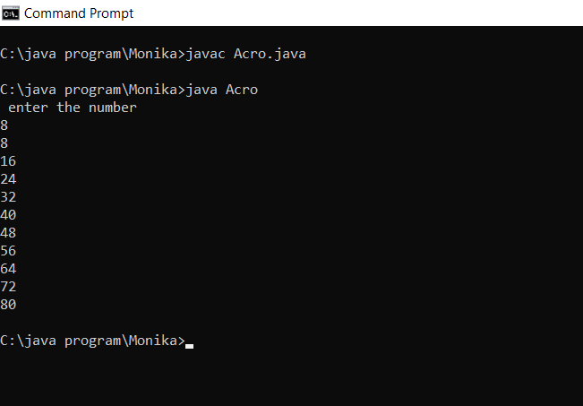

Program to print whether a number is prime or not

import java.util.\*;

class Acro {

public static void main(String[] args){

Scanner sc=new Scanner(System.in);

System.out.println(" enter the number" );

int num=sc.nextInt();

for(int i=2;i<num;i++){

if(num%i==0){

System.out.println("the number is not prime");

break;

}

else{

System.out.println("the number is prime");

break;

}

}

}

}

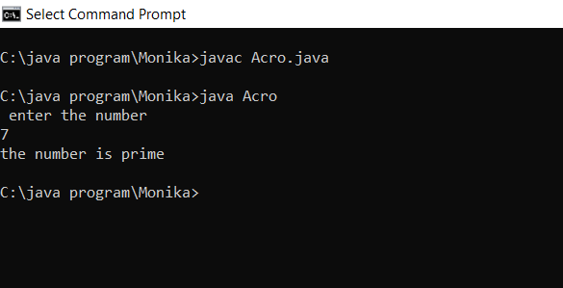

Program to print prime number from 1 to 100

import java.util.\*;

class Acro {

public static void main(String[] args){

int i, j, counter;

for (i = 2; i <= 100; i++) {

counter = 0;

for (j = 2; j <= i / 2; j++) {

if (i % j == 0) {

counter = 1;

break;

}

}

if (counter == 0)

System.out.print(i + " ");

}

}

}

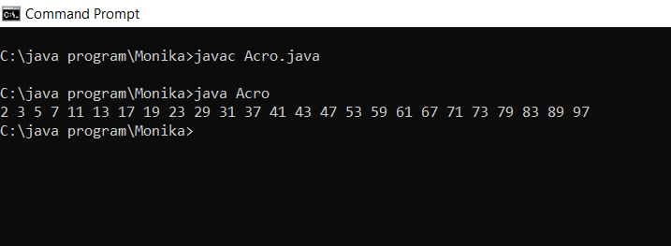

Program to use break statement

import java.util.\*;

class demo{

public static void main(String []args){

Scanner sc= new Scanner(System.in);

int n=sc.nextInt();

for(int i=1;i<=n;i++){

if(i==5)

break;

System.out.println(i);

}

}

}

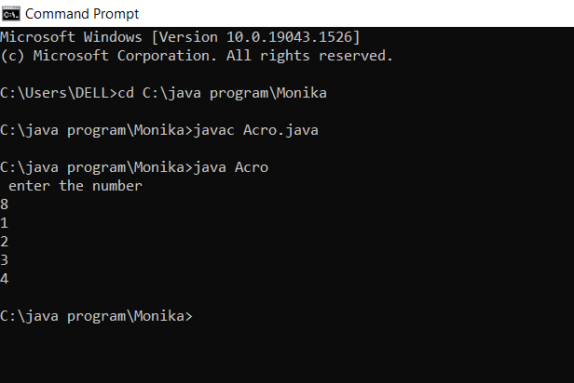

Program to use continue statement

import java.util.\*;

class demo{

public static void main(String []args){

Scanner sc= new Scanner(System.in);

int n=sc.nextInt();

for(int i=1;i<=n;i++){

if(i==5)

continue;

System.out.println(i);

}

}

}

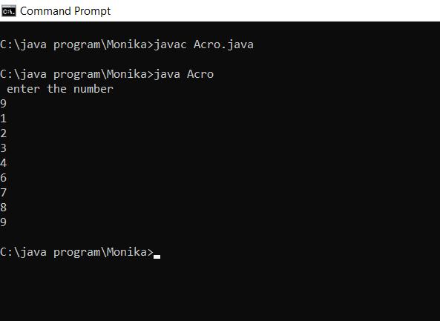

12. Make a program to find the sum of an array.

import java.util.\*;

class demo{

public static void main(String []args){

int []arr = new int[]{1,2,3,4,5};

int sum=0;

for(int i=0;i<arr.length;i++){

sum+=arr[i];

}

System.out.println("Sum of array Elements is: "+ sum);

}

}

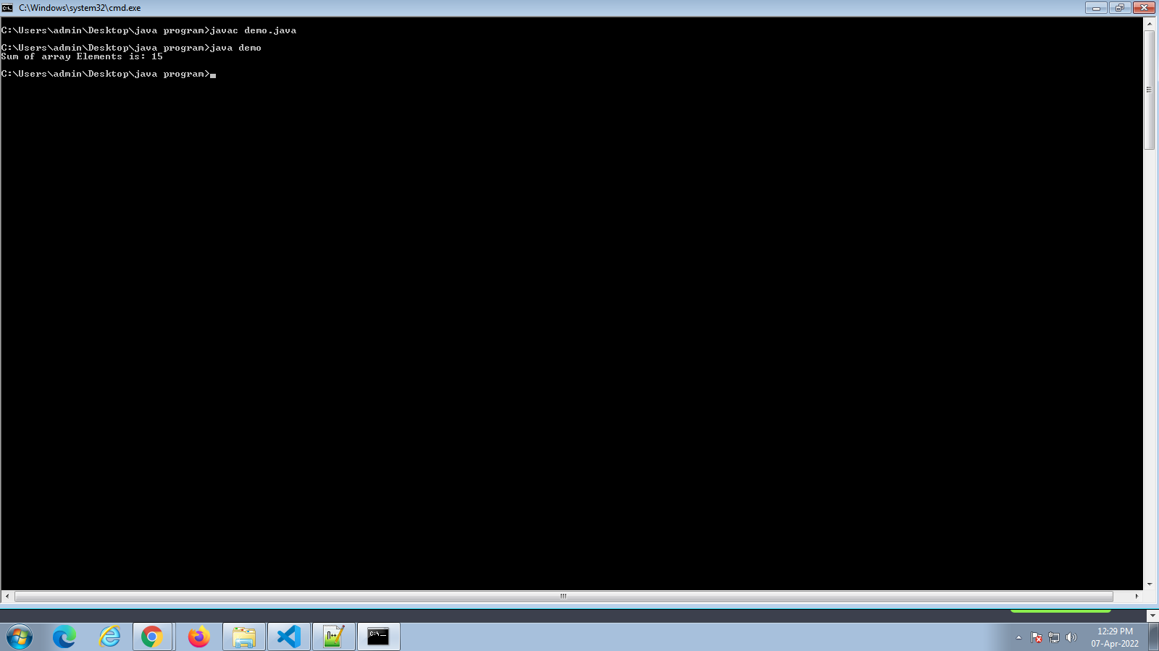

13 . Write a program to search any key in the array

import java.util.Scanner;

class demo{

public static void main(String []args){

Scanner sc = new Scanner(System.in);

int []arr = new int[]{1,2,3,4,5};

System.out.println("enter the element to be searched for ");

int key=sc.nextInt();

int flag=0;

for(int i=0;i<arr.length;i++){

if(key == arr[i]){

System.out.println("The key is found at position :" + i);

flag=1;

break;}

}

if(flag==0){

System.out.println("The key is not present in the array");

}}}

